**Supplementary Figure S1.** Distribution of non-flooded forests (dark green) and human-made water bodies (cyan dots) in the Sesc Pantanal Reserve (Brazil).

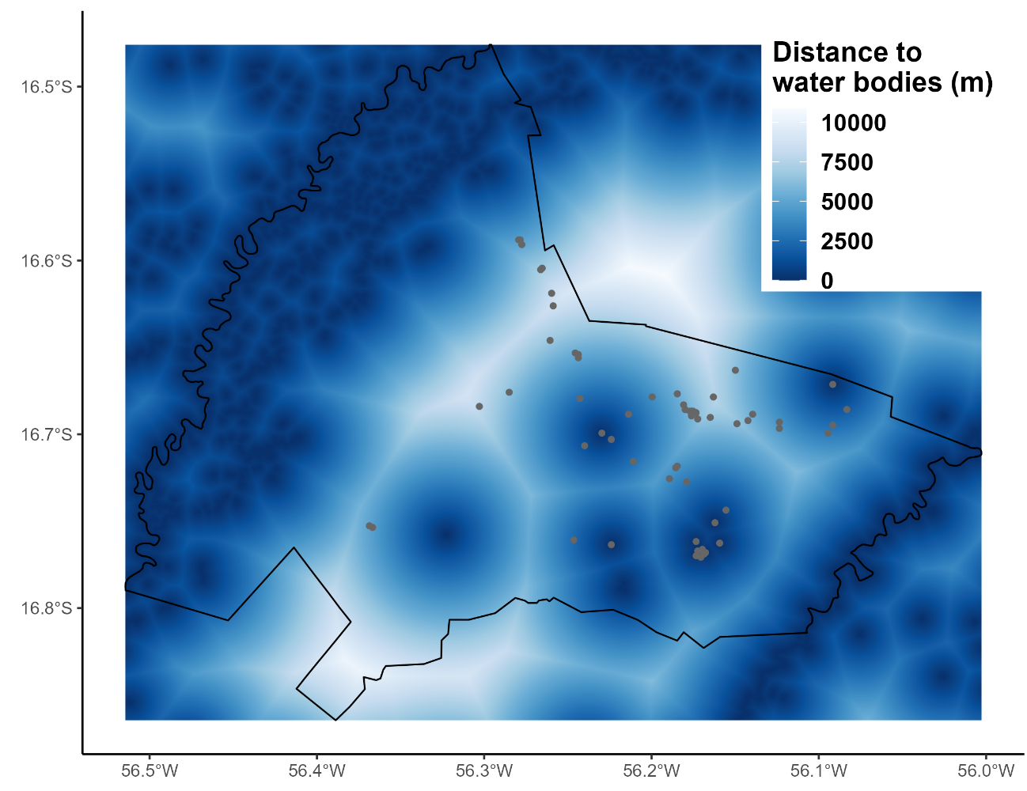

**Supplementary Figure S2.** Distance to the permanent water bodies and human-made water bodies (grey dots) in the Sesc Pantanal Reserve (Brazil).

**Supplementary Figure S3.** Severity of the 2020 Pantanal megafires in the Sesc Pantanal Reserve (Brazil) calculated from the difference Normalized Burn Ratio (dNBR) and human-made water bodies (grey dots).

**Supplementary Figure S4.** Aerial drone pictures used to characterize the 1ha sampling units, obtained after the Pantanal 2020 megafires at 110 m above ground level and perpendicular to the ground with a DJI Phantom 4 Pro. (a-l) Sampling units with different vegetation types and with variation in the severity of the 2020 wildfires. (m-n) Extraction of the proportion of green vegetation from the drone picture using a Fractional Green Canopy Cover provided by the Canopeo application.